OPERATING Systems

**Name: Girish S Roll No.: AM.EN.U4AIE22044**

--------------------------------------------------------------------------

1. **Create a file demo with the following contents**

**Student Alice Essentials 20 PSAT 22 Maths 34 Cultural 25 English 70**

**Student Bob Essentials 23 PSAT 21 Maths 32 Cultural 18 English 94**

**Student Boby Essentials 43 PSAT 31 Maths 22 Cultural 8 English 93**

**Student Clara Essentials 18 PSAT 16 Maths 27 Cultural 12 English 45**

**Student Dirck Essentials 25 PSAT 23 Maths 48 Cultural 25 English 98**

**Student Eve Essentials 8 PSAT 6 Maths 12 Cultural 13 English 5**

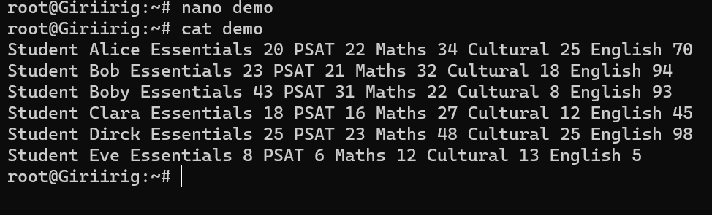

1. **Find the marks obtained by Clara in all the subjects**



1. **Print the marks for essentials in the increasing order**

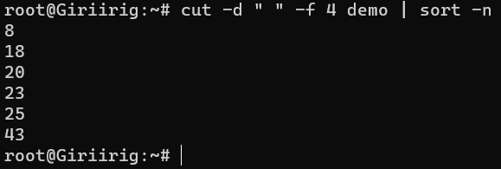

1. **Find the maximum marks scored in PSAT**

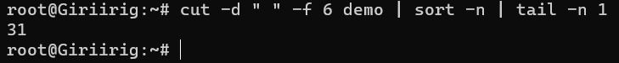

1. **Find the minimum marks obtained in Cultural**

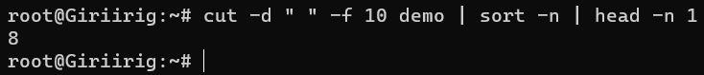

1. **Save the marks obtained by all the students in maths into a file and display it in the terminal using a single command**

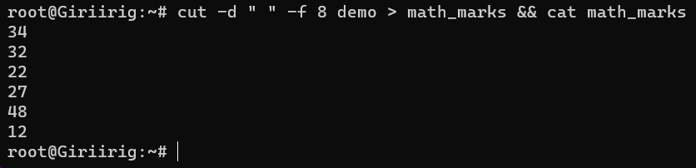

1. **Print the first 3 letters of all student names.**

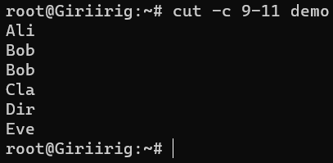

1. **Print the contents of file demo in terminal with all alphabets in capital letters.**

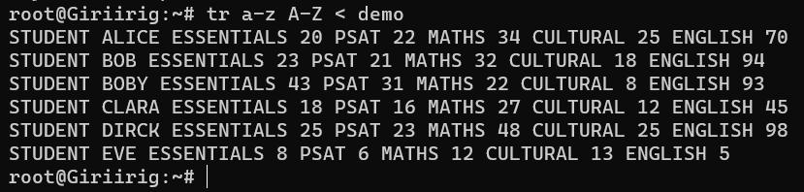

1. **Print all student names after deleting the letter ‘a’**

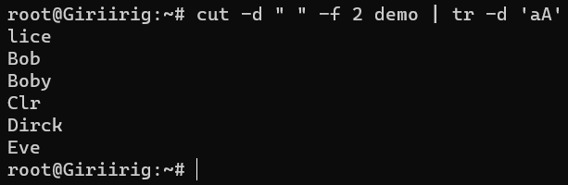

1. **Count the number of lines, words and characters in demo file after removing the letter ‘S’**

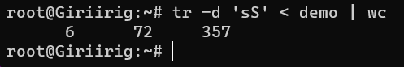

1. **Find the number of students with their names containing the letter a, e or i**

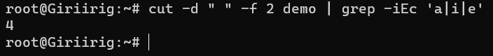

1. **Find the marks of students whose names starts with ‘b’ (case insensitive)**



1. **Find the names of students whose names starts with ‘b’ and ends with ‘y’ (case insensitive)**

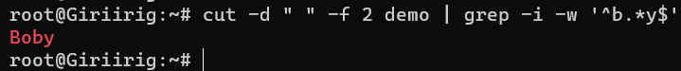

***Shell Programming***

1. **Write a shell program to perform the following actions in the given order.**

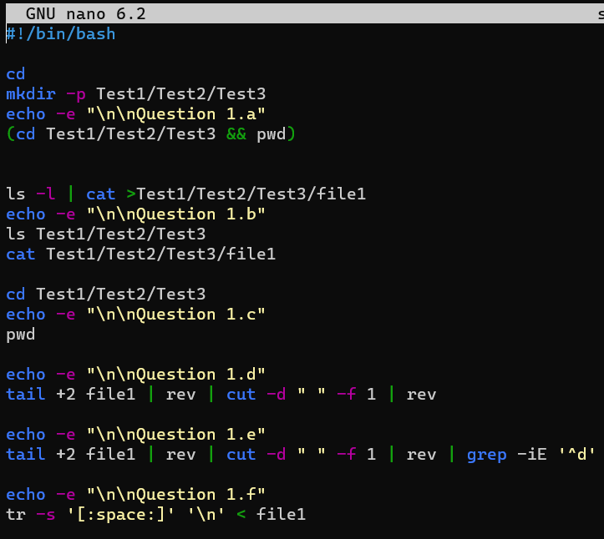

* 1. **Create a directory hierarchy in your home folder**

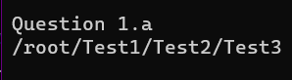

* 1. **Create a file file1 in directory Test3 with the contents same as output of the command ls -l**

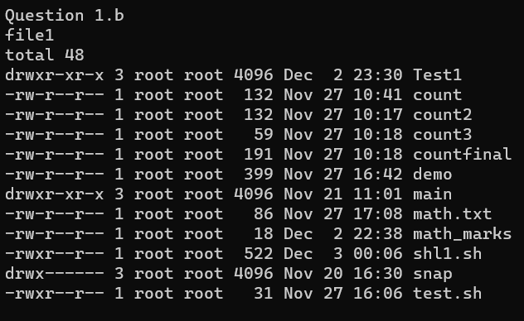

* 1. **Go to directory Test3**

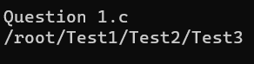

* 1. **Find the names of all files and folders in file1**

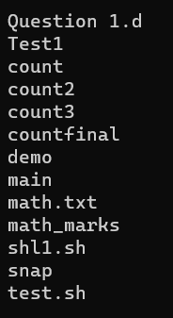

* 1. **Find the names of all files and folders starting with d(case insensitive)**

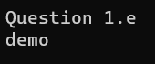

* 1. **Print all words of file1 on a separate line.**

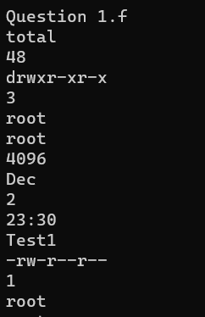

* 1. **Go back to your home directory.**

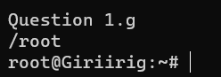

1. **Write a shell program to perform the following actions in the given order.**
   1. **Create a file numericdata with the following contents**

**Karunagappally 34567 7864 6785**

**Kollam 56754 6754 7654**

**Vallikkavu 54328 7548 45675**

**Trivandrum 16423 6654 6754**

**Ernakulam 28796 8549 9875**

**Kayamkulam 35589 75892 3451**

**kottayam 45557 6773 6547**

**tirukulum 45675 56476 7896**

**(Hint : First field is referred as Place second as code1 third as code2 and fourth as code3)**

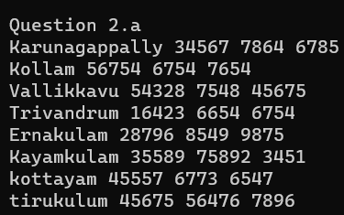

* 1. **Display the details of Places that starts with ‘T’(case sensitive)**

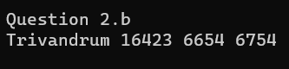

* 1. **Display code3 in sorted order(ascending) of the places that start with ‘K’(case insensitive)**

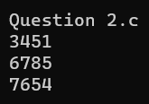

* 1. **Filter code2 that starts with 6 and ends with 4**

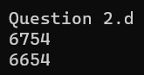

* 1. **Filter code2 having one or more occurrence of the digit 6.**

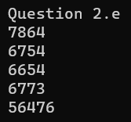

* 1. **Filter all code1 having one or more occurrence of the digit 5**

